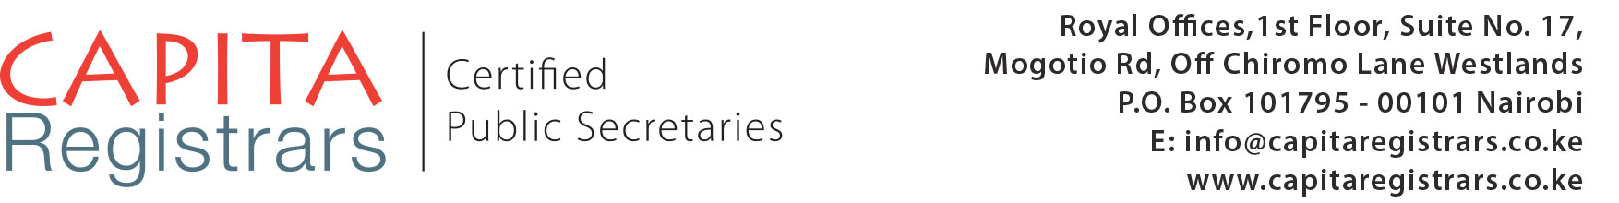
LEGALIZATION REQUEST FORM
NAME
ID/PASSPORT NUMBER
(Please submit a copy of ID/Passport)
TYPE OF DOCUMENT(S)
Number of Documents
(please list)
LEGALIZATION ON ORIGINAL/COPY
PURPOSE OF LEGALIZATION
STATE THE
EMBASSY/CONSULATE/HIGH COMMISSION
EMBASSY FEES
(Please indicate whether you would like us to submit the document to the Embassy on your behalf)
SIGNATURE

Kindly note that Legalization with Kenyan Authorities will take approximately 7 working days. The duration taken by the Embassies varies with each Embassy.
CLIENT DETAILS
Name of Client
Email Address
Phone number

Date of Submission

Please send this form to info@capitaregistrars.co.ke and copy swanjiru@capitaregistrars.co.ke
To talk to one of our consultants, please call +254709747555 or +254726328555 during working hours 8.00 a.m. to 5.00 p.m.
Notes/
- Marriage certificates, birth certificates and death certificates all need verification by the Registrars. We will charge an extra fee of US$ 20 plus the registrar fee to obtain the verification of the certificates.
- Education certificates require verification by the Ministry of Education. We will charge an extra fee of US$ 20 to obtain the verification.
- Our standard working days is seven (7) days unless there is a requirement for verification. Requirements by the Ministry of Foreign Affairs may change from time to time. Please factor in the amount of time you require e.g. for travel, school etc. and submit your documents in time. We go the extra mile to ensure that your documents are ready in good time. Also, factor in the number of days required by the embassy as each embassy requires different period of time.
- Our standard fee is US$ 250 per document plus extra charges e.g. bank charges, courier fees. Kindly request for an invoice.

